**IDCenter Photo ID Procedure**

*Please note that this procedure and associated ID project facilitates for population of a pictures only database. Generation of finalized Employee ID’s will be forthcoming as the production database is completed.*

1. Ensure that the USB License Key in inserted into the USB port on the front of the workstation. The IDCentre software will not have full functionality without this key, and is designed to prevent unauthorized use of the system.
2. Power on the workstation and Log on to the system with IDCenter AD credentials:
   1. User: IDCentreHWT
   2. Pword: Passport3
3. Launch the IDCentre Production software (shortcut on desktop) and authenticate with software security:
   1. User: Admin
   2. Pword: Admin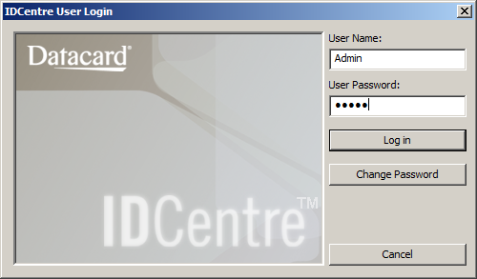
4. Select “Vertical Badge 2-20” project and Click “Open Selected Project” 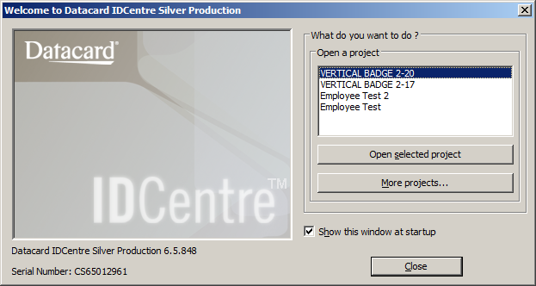
5. Two windows will open. The first is the Data and Photo entry view, and the second is the view of the badge.
6. Seat the Employee in front of the screen and Double-Click the Photo Box in the Data Entry View

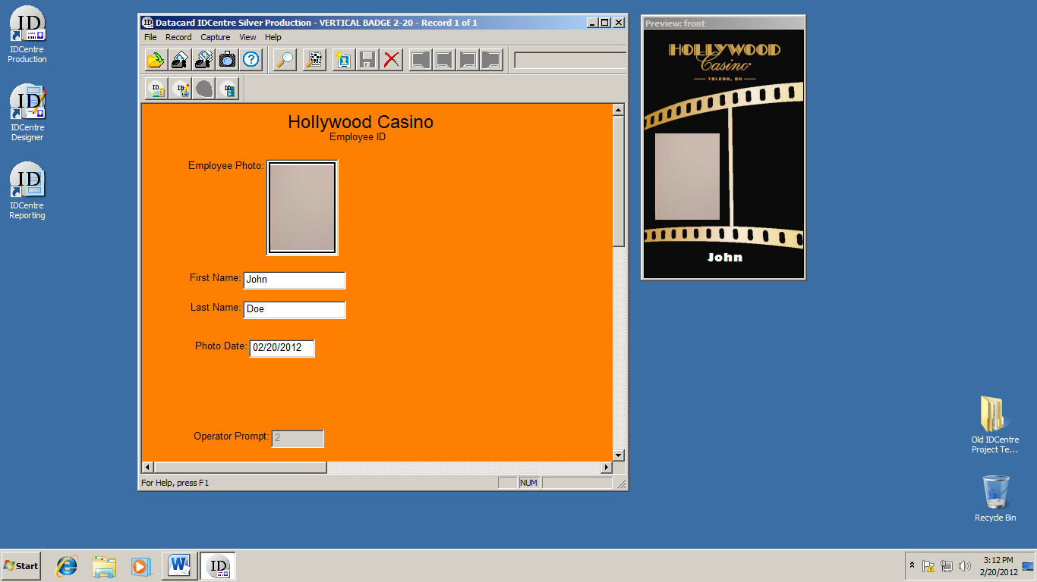

1. Click “Take Photo”. The camera will flash and the captured image will be displayed.
2. If a retake is required, double-click the photo box and retake the photo prior to moving on to the next step.
3. Type the Employees First Name and Last Name in the prompt boxes and Click the “Save” icon from the window toolbar.

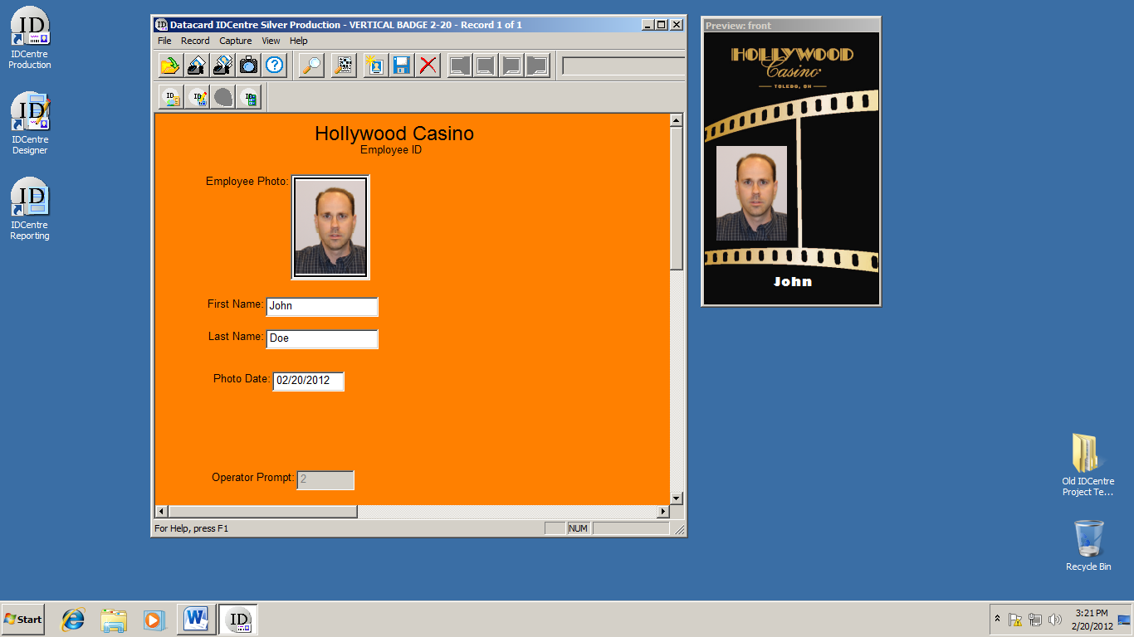

1. Upon saving, the employee image will be saved to the server and the process from step 6 will be repeated for each employee.
2. When photo sessions are complete, ***SECURE THE USB LICENSE KEY AND CAMERA*** and shut down the workstation.